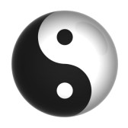 | HERITAGE Tai Chi & Kung Fu  The Soft Circle Method of Tai Chi  The 4 Pre-requisites  The 3 Moving Requirements  The 6 Still Requirements | 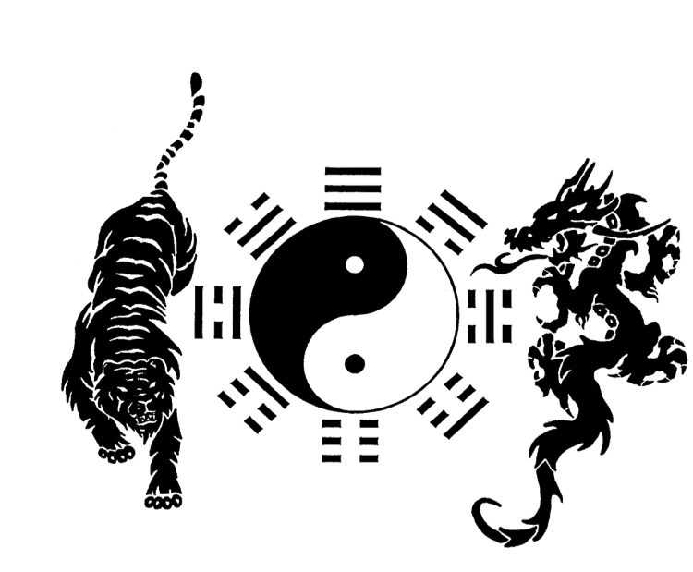

FOUR PRE-REQUISITES
Before beginning Tai Chi, there are four pre-requisites:

- ENVIRONMENT
- The space feels comfortable and peaceful
- Your clothing – you want to be comfortable

- FELLOW STUDENTS – COMMUNITY – PRACTICE PARTNERS
- Welcoming to new students
- Respecting and enjoying being with your fellow students

- TEACHER – METHOD
- There are many methods to get to Tai Chi
- To understand the method you have to be like the Monkey which is clever and adaptable and also like the Ox which perseveres and keeps going and doesn’t listen to the monkey that tells you to quit.
- Tai chi is all about accumulating – building interest in your “mind & body” wealth.
- If you’re not getting anywhere, you have to look inward. Get outside the box. What are you not seeing? You need to discover the truth.

- RICH
- Rich in Health
- Rich in Spirit
- Rich in an appreciation of where you are and what you have
- Health is $$

HERITAGE Tai Chi & Kung Fu
The Soft Circle Method of Tai Chi

The 4 Pre-requisites
The 3 Moving Requirements
The 6 Still Requirements

SIX STILL REQUIREMENTS
You can see the Still Body Requirements in a photo.
The body should be in a perfect position in every snapshot and the result of
doing this correctly is balance. It’s a living suit of armor.

The head moves with the body with the body underneath the head. Like a Cheetah.

The 6 Still Body Requirements are:
1. HEAD-MIND
2. CHEST-HEART
3. SHOULDERS
4. WAIST
5. DANG – PELVIC FLOOR
6. BREATH

HEAD - MIND | - How it relates to the body physically, mentally & energetically  - Head up – chin in – positive attitude – YES!  - How it is attached to the torso. How it connects to the body.  - Don’t lead with the chin.  - Head is resting on the body  - The ribs are helping the shoulders hold the head  - Breathe into the head and neck point that connects to the torso  HEAD-NECK CONNECTION  - Neck movement comes from beneath the neck.  - Keep the head up and the chin in.  - Like a cork
CHEST – HEART | - Has to be relaxed – represents heart  - Calm emotions  - Movement is not a lot here, but it’s there and is independent  - Upper Torso (rib cage and upper spine) - chest connects to back & neck.  - Heart-chest-back: rib cage, no spine, no arms, breathe into your ribs  - Soft, contained, comes out the back
SHOULDERS - BURDEN | - SHOULDERS CARRY OUR BURDEN – they should be resting and always DOWN as they connect to elbow, hands, center. Release and relax your shoulders to release your burden.  - Shoulders & Arms (The arm is part of the shoulder) are sitting on top and should do the following:  - Think of it as attached to chest & head  - Connect to torso: when you think of shoulders, think of how it connects to the torso and rests on top of it  - Connect down the back  - Shoulders connect to the breastplate, pulling scapula in.  - The scapula PULL DOWN to LIFT the arm (like a door pulley – to open a door, the weight goes down)  - Shoulder also goes into the head  - The outside shoulder is the arms.  - Arms are the external part of shoulders
WAIST | The waist is from the lower ribs to the hips. Fill it with air. Dantien is in this area.  “Every part of your body must relate to your center which can be a direct physical connection. However, most of the time it is more of a communicative connection. Every part of the body is independent & free yet united and working to support each other. Even if one part of the body is moving independently it must always keep it’s relationship through communication with the center.”
DANG – PELVIC FLOOR - PERINEUM | End of tailbone as it related to the knees  Connects to knees and hips & involves pelvic floor.  - Dang  - Center Point – a little lift  - There’s an energy point there – Chakra #1  - The bridge between the legs  - Inner thighs to knees and up to hips  - Where everything connects  - Lift the Pot  - Perineum, pelvic floor and other muscles connecting to legs  - Think of it as your pot – if it’s weak, energy will pour out.  - Dang connects to the knees
BREATH | Last and first of the six still requirements – breath feeds the positive attitude – it’s on a circle.  - Breath is the fuel – quiet, peaceful breath  - Can feed positive or negative energy  - You can see breath in a photo – no stress shows in the body

HERITAGE Tai Chi & Kung Fu
The Soft Circle Method of Tai Chi

The 4 Pre-requisites
The 3 Moving Requirements
The 6 Still Requirements

THREE MOVING BODY REQUIREMENTS
CIRCLES: everything is a circle

ROTATION: gives dimension to the circles

POSITION: movement & timing

USE THE STILL REQUIREMENTS WHILE MOVING

CIRCLE | “We must find the circle in every movement.”  Grandmaster Liu Rui.  Find the circle in the movement and the  inner circle in the body.  - What does this mean? Our style of Tai Chi is Zhao Bao. And the method we use is “the soft circle method”.  - Circles lead into other circles and create the Form.  - To find the circle is to find tai chi.  - In a martial arts reference, an opponent cannot stick to a continuously moving circle.
ROTATION | Rotation: The Power.  Makes the Circle 3 dimensional.  - The Yin Yang symbol represents Tai Chi. The sides of black and white are opposite, but balanced. The white has a touch of black and the black a touch of white; again balanced.  - Opposites continuously moving together, to create a perpetual circle.  - Dark, light; Top, bottom; Soft, hard; Quick, slow; Empty, full.
POSITION | Timing is part of the Position Requirement  - Proper placement of the body

